UX Design Receiving by Tim Salinas

# **ERD for UX process**

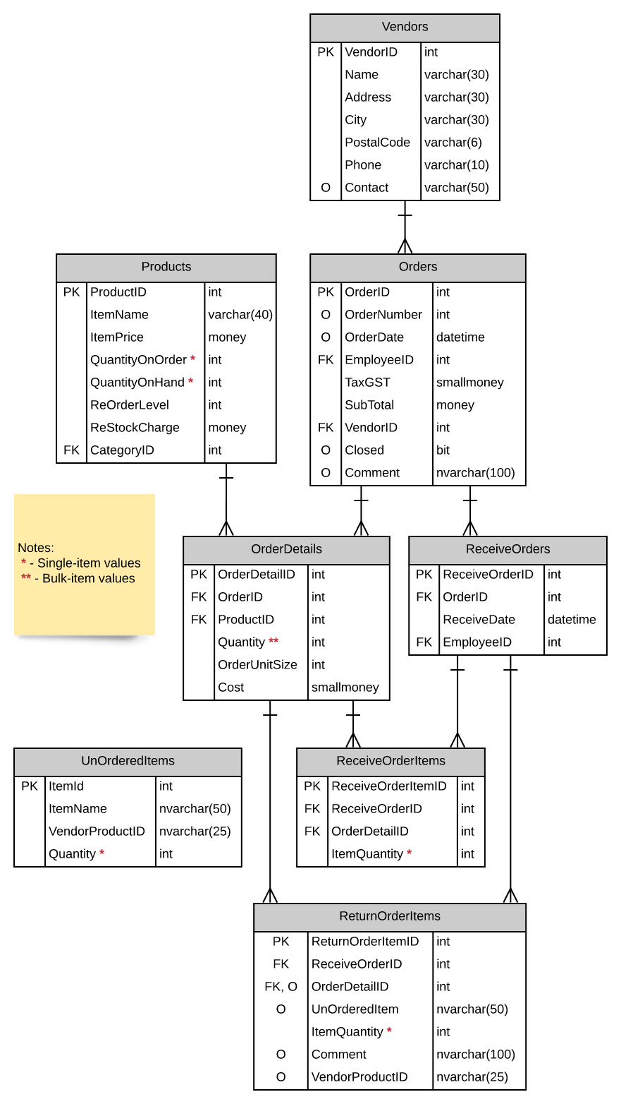

# **Possible UX Interface**

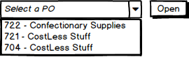

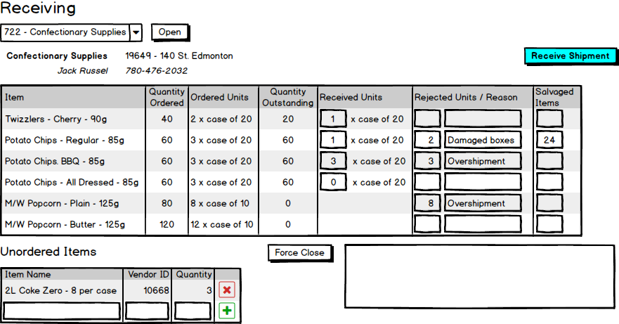

**Notes:**

* The above UI layout is just a simple draft.
* Bootstrap and other CSS styles will be used to streamline UI later on.

# **ViewModels**

public class VendorSelectionListItem

{

public int VendorID { get; set; }

public string Name { get; set; }

public string Address { get; set; }

public string Phone { get; set; }

public string Contact { get; set; }

}

public class ProductListItem

{

public int ProductID { get; set; }

public string ItemName { get; set; }

public int QuantityOrdered { get; set; }

public int OrderedUnits { get; set; }

public int QuantityOutstanding { get; set; }

public int ReceivedUnits { get; set; }

public int RejectedUnits { get; set; }

public string RejectedReason { get; set; }

public int SalvagedItems { get; set; }

}

public class UnorderedItemsListItems

{

public int ItemID { get; set; }

public string ItemName { get; set; }

public int VendorProductID { get; set; }

public int Quantity { get; set; }

}

# **ViewModels (Continued)**

public class ReceiveOrders

{

public int ReceiveOrderID { get; set; }

public string OrderID { get; set; }

public int ReceiveDate { get; set; }

}

# **Event and Wiring Summations**

**Vendor Select Dropdown**

public List<VendorSelectionListItem> VendorList () {…}

**Notes:**

* Gets the list of vendors and returns ID values and names

**Received Items List**

public ProductListItem ProductListItemByID(int productid) {…}

**Notes:**

* Gets the product name, quantity ordered, ordered units, quantity outstanding, received units, rejected units, rejected reason, and salvaged items.
* Will be displayed once “Open” button is clicked.

**Unordered Items List**

public UnorderedItemsListItems UnorderedItemsListItemsByID(int itemid) {…}

**Notes:**

* Gets the list of unordered items with the item name, vendor ID, and quantity.

**Receive Shipment**

public ReceiveOrders ReceiveOrdersShipment(int ReceiveOrderID) {…}

**Notes:**

* Receive order entry will be made once “Receive Shipment” button is clicked.